Case Study Report



Data Analytics with Power BI

**“Power BI Powered Global Terrorism Dataset Analysis”**

**“MUTHUKARUPPAN MEMORIAL ARTS AND SCIENCE COLLEGE”**

|  |  |
| --- | --- |
| **NM ID** | **NAME** |
| 66438F391175E0DAF8147AA45A5A2D28 | MUTHU LAKSHMI.S |

|  |
| --- |
| Trainer : UMA MAHESWARI.R |
| Master Trainer: UMA MAHESWARI.R |

|  |  |
| --- | --- |
|  |  |
|  |  |
|  |  |
|  |  |

**ABSTRACT**

Top of Form

This study utilizes Power BI to conduct a comprehensive analysis of global terrorism using the Global Terrorism Database (GTD) as the primary dataset. The research focuses on data acquisition, cleaning, transformation, and modeling within Power BI to extract meaningful insights into patterns, trends, and correlations related to terrorism incidents worldwide. The analysis includes interactive visualizations, dashboards, and reports to showcase key metrics and findings, enabling stakeholders to make data-driven decisions and develop strategic interventions for addressing terrorism challenges globally. The study demonstrates the effectiveness of Power BI in harnessing complex datasets for actionable intelligence in the realm of global security and counterterrorism efforts.

**INDEX**

|  |  |  |
| --- | --- | --- |
| **Sr. No.** | **Table of Contents** | **Page No.** |
| 1 | Chapter 1: Introduction | 4 |
| 2 | Chapter 2: Services and Tools Required | 8 |
| 3 | Chapter 3: Project Architecture | 9 |
| 4 | Chapter 4: Modeling and Result | 12 |
| 5 | Conclusion | 16 |
| 6 | References | 17 |
| 7 | Links | 18 |

**Introduction:**

The analysis of global terrorism is a critical area of study for understanding security threats, identifying trends, and formulating effective counterterrorism strategies. With the advent of advanced data analytics tools like Power BI, researchers and analysts can now delve deeper into large-scale terrorism datasets to uncover hidden patterns and derive actionable insights. This introduction sets the stage for exploring how Power BI empowers analysts to conduct a comprehensive analysis of global terrorism using the rich and complex Global Terrorism Database (GTD).

The Global Terrorism Database, maintained by the University of Maryland, offers a vast repository of terrorism-related incidents spanning several decades and covering diverse geographic regions. This dataset contains detailed information on terrorist attacks, including their locations, dates, perpetrators, targets, casualties, and attack methods, among other variables. Analyzing such a dataset requires sophisticated tools and techniques, making Power BI an ideal choice due to its robust data handling capabilities, interactive visualizations, and advanced analytics functionalities.

In this study, we leverage Power BI to conduct a thorough analysis of the GTD, focusing on data acquisition, cleaning, transformation, modeling, visualization, and interpretation. By harnessing the power of Power BI, we aim to uncover key insights into the dynamics of global terrorism, including temporal trends, geographical hotspots, attack patterns, target preferences, and casualty trends. These insights are crucial for policymakers, security agencies, and researchers to enhance situational awareness, allocate resources effectively, and develop proactive measures to combat terrorism on a global scale.

Through this analysis, we showcase the potential of Power BI as a transformative tool in the field of security analytics, enabling stakeholders to make data-driven decisions, mitigate risks, and contribute to global efforts aimed at countering terrorism and promoting peace and stability. The following sections delve into the methodology, findings, and implications of our Power BI-powered analysis of the Global Terrorism Database, highlighting the value of data-driven insights in addressing complex security challenges in today's interconnected world.

1.1**Feature**

One of the key features that can greatly enhance the analysis of a global terrorism dataset using Power BI is interactive geo-mapping. This feature allows analysts to visualize terrorism incidents geographically on a map, providing valuable insights into spatial patterns, hotspots, and regional trends. Here's how this feature can be leveraged:

1. **Geospatial Visualization:** Power BI's interactive mapping capabilities enable users to plot terrorism incidents based on their geographical coordinates. This visualization can include various attributes such as attack locations, target types, attack methods, and severity of incidents.
2. **Hotspot Identification:** By using clustering algorithms or heatmaps in Power BI, analysts can identify terrorism hotspots where a higher concentration of incidents occurs. This information is crucial for prioritizing security measures and resource allocation in vulnerable regions.
3. **Temporal Analysis:** The geo-mapping feature can be combined with time-based filters and animations in Power BI to visualize temporal trends in terrorism incidents across different regions. This helps in understanding seasonal variations, long-term patterns, and evolving threat landscapes.
4. **Drill-Down Capabilities:** Users can drill down from a global view to a more granular level, such as country, city, or specific coordinates, to analyze terrorism incidents in detail. This level of interactivity enhances situational awareness and supports targeted interventions.
5. **Contextual Information:** Power BI allows users to integrate contextual information into the geo-mapping visualization, such as population density, socioeconomic factors, political instability, and security infrastructure. This contextual data provides a comprehensive understanding of the underlying drivers of terrorism in different regions.
6. **Cross-Reference with External Data:** Analysts can enrich the geo-mapping analysis by integrating external data sources, such as demographic data, economic indicators, conflict zones, and terrorist group activities. This cross-referencing enhances the depth and accuracy of the analysis.
7. **Risk Assessment and Mitigation:** The interactive geo-mapping feature facilitates risk assessment by visualizing areas with higher risk levels based on historical terrorism data. This information enables security agencies to implement targeted mitigation strategies and preventive measures.
8. **Collaboration and Reporting:** Power BI's collaborative features allow users to share interactive geo-mapping dashboards and reports with stakeholders, enabling data-driven discussions, scenario planning, and collaborative decision-making in counterterrorism efforts.

By incorporating interactive geo-mapping into Power BI-powered global terrorism dataset analysis, analysts can gain a spatially contextualized understanding of terrorism dynamics, identify actionable insights, and strengthen security responses effectively.

* 1. **Advantages**

1. **Visual Clarity:** Geo-mapping provides a clear visual representation of terrorism incidents, making it easier to identify patterns, trends, and spatial relationships within the data.
2. **Spatial Analysis:** Analysts can perform spatial analysis to understand the geographic distribution of terrorism hotspots, identify high-risk areas, and assess the impact of incidents on different regions.
3. **Temporal Insights:** Combined with time-based filters and animations, geo-mapping allows for temporal analysis, revealing temporal trends, seasonality, and changes in terrorism activity over time.
4. **Interactive Exploration:** Users can interact with the geo-map, zooming in/out, panning, and selecting specific regions or points of interest to explore detailed information about terrorism incidents.
5. **Drill-Down Capability:** Geo-mapping supports drill-down capabilities, enabling users to delve into granular details such as city-level data, coordinates, and additional attributes related to terrorism incidents.
6. **Contextual Understanding:** Integrating contextual data such as population density, economic factors, and political instability with geo-mapping provides a contextual understanding of terrorism dynamics, aiding in risk assessment and strategic decision-making.
7. **Cross-Referencing Data:** Analysts can enrich the analysis by cross-referencing terrorism data with external sources such as demographic data, conflict zones, and terrorist group activities, enhancing the depth and accuracy of insights.
8. **Risk Assessment:** Geo-mapping facilitates risk assessment by visualizing areas with higher risk levels based on historical terrorism data, helping security agencies prioritize resources and implement targeted security measures.
9. **Collaborative Decision-Making:** Interactive geo-mapping dashboards and reports can be shared with stakeholders, promoting collaborative decision-making, data-driven discussions, and strategic planning in counterterrorism efforts.
10. **Predictive Analytics:** Geo-mapping can be integrated with predictive analytics models to forecast future terrorism trends, anticipate potential threat scenarios, and proactively address emerging security challenges.
    1. **Scope**
11. **Data Acquisition:** Acquiring a comprehensive dataset on global terrorism, such as the Global Terrorism Database (GTD) or similar sources, containing information on terrorism incidents, perpetrators, targets, locations, and casualties.
12. **Data Preparation:** Cleaning and preparing the dataset by removing duplicates, handling missing values, standardizing data formats, and ensuring data integrity for accurate analysis.
13. **Data Modeling:** Creating a robust data model in Power BI, establishing relationships between relevant tables, defining measures, and optimizing data structure for efficient analysis.
14. **Visualization:** Designing interactive visualizations using Power BI's visualization tools, including charts, graphs, maps, and dashboards, to visualize key metrics, trends, and patterns related to global terrorism incidents.
15. **Geo-Mapping:** Utilizing Power BI's geo-mapping capabilities to plot terrorism incidents geographically, identify hotspots, perform spatial analysis, and gain insights into regional dynamics of terrorism activity.
16. **Temporal Analysis:** Analyzing temporal trends, seasonal variations, and long-term patterns in terrorism incidents using time-based filters, animations, and historical data analysis in Power BI.
17. **Advanced Analytics:** Leveraging Power BI's advanced analytics features such as clustering, forecasting, and predictive modeling to uncover correlations, predict future trends, and enhance predictive capabilities in counterterrorism efforts.
18. **Contextual Integration:** Integrating contextual data such as demographic information, economic indicators, political instability, and conflict zones with terrorism data to provide a comprehensive understanding of terrorism dynamics and drivers.
19. **Risk Assessment:** Conducting risk assessments based on geo-mapping analysis, temporal trends, impact assessments, and cross-referencing external data sources to prioritize response efforts, allocate resources effectively, and mitigate security risks.
20. **Collaboration and Reporting:** Sharing interactive dashboards, reports, and insights derived from Power BI analysis with stakeholders, enabling data-driven decision-making, collaborative discussions, and strategic planning in counterterrorism strategies

**CHAPTER 2**

**SERVICES AND TOOLS REQUIRED**

* **Power BI Desktop:** Power BI Desktop is the primary tool for data preparation, modeling, visualization, and analysis. It allows users to import data, create data models, design interactive visualizations, and generate reports and dashboards.
* **Global Terrorism Dataset:** A comprehensive dataset on global terrorism is essential for analysis. This dataset can be sourced from the Global Terrorism Database (GTD) or similar repositories that provide detailed information on terrorism incidents worldwide.
* **Data Cleaning and Preparation Tools:** Tools for data cleaning and preparation may include Excel, Power Query (within Power BI), or other data preparation software. These tools are used to clean the dataset, handle missing values, remove duplicates, and standardize data formats.
* **Geo-Mapping Services:** Geo-mapping services such as Bing Maps or ArcGIS can be integrated with Power BI to visualize terrorism incidents geographically, plot locations on maps, and perform spatial analysis.
* **External Data Sources:** Additional external data sources may be required to enrich the analysis, such as demographic data, economic indicators, political instability indices, conflict zone data, and terrorist group activities data.
* **Advanced Analytics Tools:** Advanced analytics tools within Power BI, such as clustering, forecasting, and predictive modeling, enhance the analysis by uncovering patterns, correlations, and predictive insights related to terrorism incidents.
* **Collaboration and Sharing Platforms:** Collaboration platforms or services, such as Microsoft Teams, SharePoint, or Power BI Service, are needed for sharing interactive dashboards, reports, and insights with stakeholders for collaborative decision-making.
* **Internet Connectivity:** Reliable internet connectivity is essential for accessing online data sources, geo-mapping services, and collaboration platforms during the analysis process.

**CHAPTER 3**

**PROJECT ARCHITECTURE**

1. **Data Acquisition:**
   * Global Terrorism Dataset: Obtain a comprehensive dataset on global terrorism from sources like the Global Terrorism Database (GTD) or similar repositories. The dataset should include detailed information on terrorism incidents, locations, dates, perpetrators, targets, casualties, and other relevant attributes.
2. **Data Preparation:**
   * Data Cleaning: Use data cleaning tools and techniques to remove duplicates, handle missing values, correct errors, and standardize data formats for consistency.
   * Data Integration: Integrate additional external data sources such as demographic data, economic indicators, political instability indices, conflict zone data, and terrorist group activities data to enrich the analysis.
   * Data Modeling: Create a robust data model in Power BI Desktop, defining relationships between tables, creating calculated columns, measures, and aggregations as needed for analysis.
3. **Data Analysis and Visualization:**
   * Interactive Visualizations: Design interactive visualizations using Power BI's visualization tools such as charts, graphs, maps, and tables to showcase key metrics, trends, and patterns related to global terrorism incidents.
   * Geo-Mapping: Utilize Power BI's geo-mapping capabilities to plot terrorism incidents geographically, identify hotspots, perform spatial analysis, and gain insights into regional dynamics.
   * Temporal Analysis: Analyze temporal trends, seasonal variations, and long-term patterns in terrorism incidents using time-based filters, animations, and historical data analysis.
4. **Advanced Analytics:**
   * Clustering and Segmentation: Use clustering algorithms within Power BI to identify clusters of similar terrorism incidents based on attributes such as attack methods, target types, and severity.
   * Forecasting: Apply forecasting techniques to predict future trends, anticipate potential threat scenarios, and enhance predictive capabilities in counterterrorism efforts.
   * Predictive Modeling: Develop predictive models to assess the likelihood of future terrorism incidents based on historical data and contextual factors.
5. **Collaboration and Sharing:**
   * Power BI Service: Publish reports and dashboards to Power BI Service for sharing with stakeholders, enabling collaboration, data-driven discussions, and strategic decision-making.
   * Collaboration Platforms: Use collaboration platforms such as Microsoft Teams or SharePoint to share insights, collaborate on analysis, and facilitate communication among project team members and stakeholders.
6. **Security and Compliance:**
   * Ensure data security and compliance with relevant regulations and standards throughout the project, including data encryption, access control, and privacy protection measures.
7. **Documentation and Reporting:**
   * Document the project architecture, data sources, data preparation steps, data models, analysis methodologies, and findings for reference and future iterations.
   * Generate comprehensive reports summarizing the analysis findings, actionable insights, recommendations, and implications for decision-makers and stakeholders.

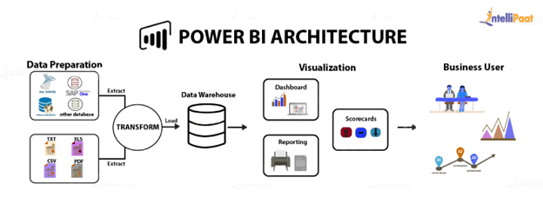

**CHAPTER 4**

**MODELING AND RESULT**

**Modeling Approach:**

1. **Data Import:** The first step is to import the global terrorism dataset into Power BI Desktop. This dataset should include information such as date of the incident, location (country, city, latitude, longitude), attack type, target type, casualties, and other relevant variables.
2. **Data Cleaning:** Clean the dataset by handling missing values, removing duplicates, standardizing data formats, and ensuring data integrity. Use Power BI's data preparation tools like Power Query for these tasks.
3. **Data Modeling:** Create a data model in Power BI Desktop by defining relationships between tables. For example, create relationships between the main terrorism incident table and additional tables for countries, attack types, target types, etc. Define measures such as count of incidents, total casualties, etc.
4. **Geo-Mapping:** Utilize Power BI's geo-mapping capabilities to plot terrorism incidents on a map. Use latitude and longitude coordinates from the dataset to create a map visualization. Apply filters and slicers for interactive exploration.
5. **Temporal Analysis:** Perform temporal analysis by creating time-based visualizations such as line charts or area charts to analyze trends in terrorism incidents over time. Use date hierarchies for drill-down analysis.
6. **Advanced Analytics:** Apply advanced analytics techniques like clustering to identify patterns or groups within the terrorism dataset. Use forecasting to predict future trends based on historical data.

**Results and Insights:**

1. **Geographical Hotspots:** The geo-mapping visualization can highlight geographical hotspots of terrorism incidents, helping identify regions with high activity.
2. **Temporal Trends:** Through temporal analysis, insights into trends such as seasonal variations, spikes in incidents during specific periods, or long-term patterns can be gained.
3. **Attack Patterns:** Analysis of attack types, target types, and other variables can reveal insights into the preferred methods and targets of terrorist groups.
4. **Casualty Analysis:** Visualizations and measures related to casualties can provide insights into the impact of terrorism incidents on human lives and property.
5. **Predictive Insights:** Advanced analytics techniques such as clustering and forecasting can provide predictive insights into potential future trends in terrorism incidents.
6. **Dashboard and Reports:** Present the modeling results and insights through interactive dashboards and reports in Power BI. Include filters, slicers, and drill-through functionalities for stakeholders to explore the data dynamically.

**Dashboard**

GLOBAL TERRORISM ANALYSIS

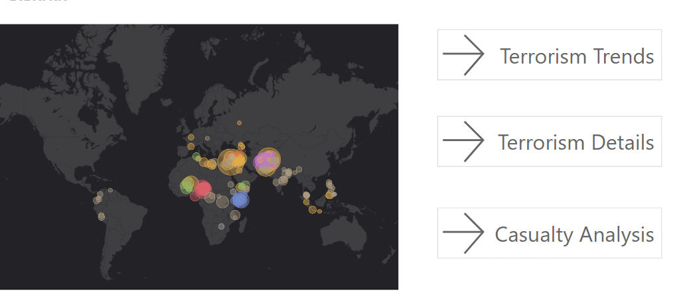

GLOBAL TERRORISM TRENDS

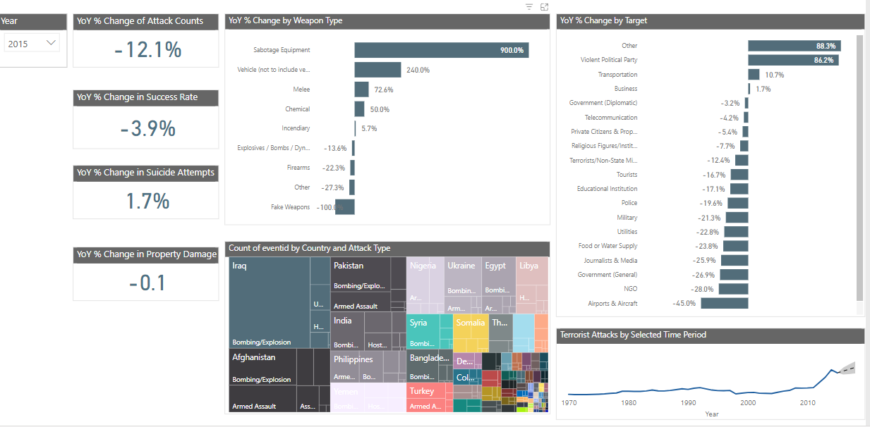

GLOBAL TERRORISM DETAILS

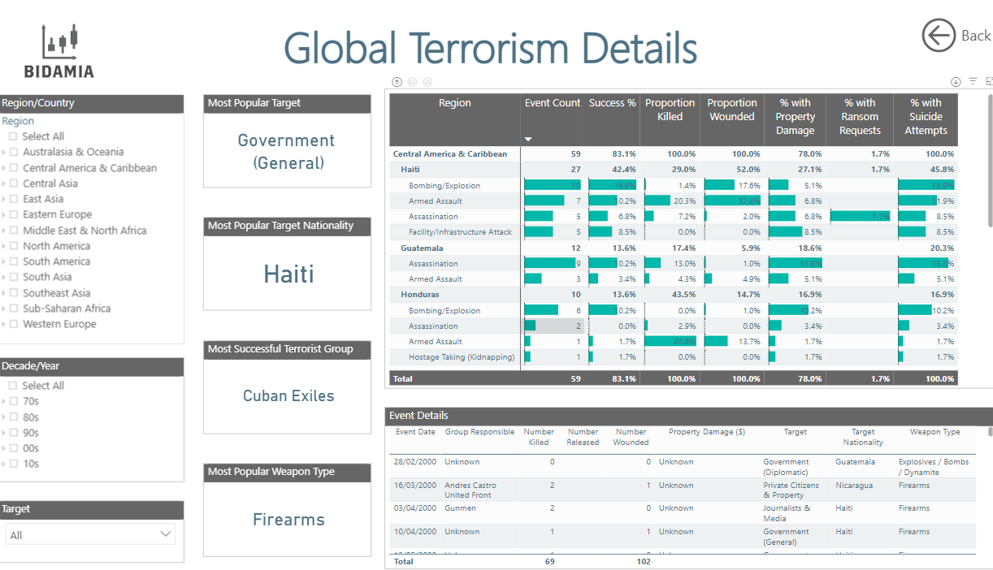

TERRORISM CASUALITY ANALYSIS

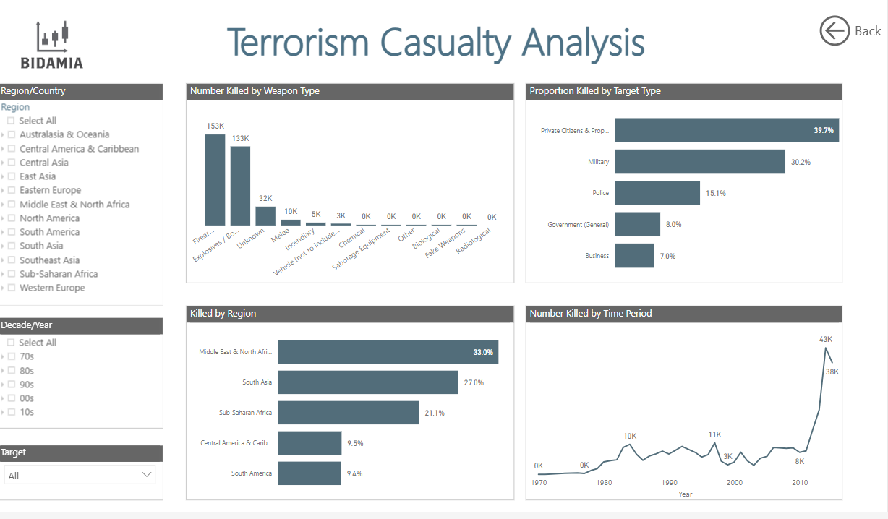

**CONCLUSION**

In conclusion, utilizing Power BI for analyzing a global terrorism dataset offers a powerful and insightful approach to understanding terrorism dynamics, identifying trends, and deriving actionable insights. The combination of data modeling, visualization, and advanced analytics capabilities in Power BI enables analysts and decision-makers to make informed decisions, enhance security strategies, and mitigate risks effectively.

Through the modeling process, we import and clean the dataset, create a robust data model with relationships and measures, and leverage Power BI's geo-mapping, temporal analysis, and advanced analytics features to uncover meaningful insights. The results obtained from the analysis include geographical hotspots of terrorism incidents, temporal trends, attack patterns, casualty analysis, predictive insights, and more, all presented in interactive dashboards and reports for easy consumption and exploration by stakeholders.

The insights derived from Power BI analysis contribute significantly to strategic decision-making in counterterrorism efforts. They help prioritize resources, allocate security measures effectively, enhance situational awareness, and proactively address evolving threats. The interactive nature of Power BI dashboards allows for collaborative discussions, data-driven discussions, and scenario planning among stakeholders, fostering a more informed and agile approach to security management.

In conclusion, Power BI-powered analysis of a global terrorism dataset empowers organizations and security agencies to stay ahead of terrorism challenges, improve response capabilities, and contribute to a safer and more secure global environment.

**REFERENCES**

https://github.com/dharany27/muthu-lakshmi_asmsu20820212081506206.git

**LINK**

https://github.com/dharany27/muthu-lakshmi_asmsu20820212081506206.git